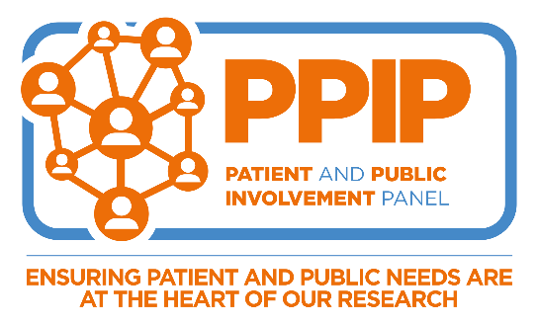

Patient and Public Involvement Panel - Application Form
Thank you for your interest in volunteering to become a member of the Bone Cancer Research Trust’s Patient and Public Involvement Panel (PPIP). Please complete all sections of this form.
Once completed, please submit your application to the Bone Cancer Research Trust Research Team - research@bcrt.org.uk

1. Personal details

Surname |  | Phone number (mobile)
Other names |  | Phone number (work)
Address |  | Email address (personal)
 |  | Email address (work)
 |  | Can we contact you at work? | Yes ☐ No ☐
Please confirm you are over the age of 18 |  |  | ☐

2. Life experience of primary bone cancer

What best describes you?

Please select one of the following:

Current patient | ☐ | Parent of a patient | ☐
Former patient | ☐ | Bereaved parent | ☐
A friend or other family member of a patient | ☐ | A bereaved friend or other family member | ☐

What type of primary bone cancer does your experience relate to?

Osteosarcoma | ☐
Ewing | ☐
Chondrosarcoma | ☐
Chordoma | ☐
Spindle Cell Sarcoma of the Bone | ☐
Adamantinoma | ☐
Angiosarcoma of the Bone | ☐
Giant Cell Tumour of the Bone | ☐
Other | ☐
If ‘Other’ please specify

Treatment location

The Bone Cancer Research Trust is committed to funding research in a fair and transparent manner. To do this, we must ensure that those involved in funding decisions do so in an independent manner and do not have conflicts of interest.

Please summarise below where your treatment, or your family member’s treatment took place:

3. Skills and Experience

Members of the Patient and Public Involvement Panel act in a lay capacity; however, please tell us about any relevant experience or employment information where you may have reviewed documentation and taken part in group discussions.

Are there any areas of research you have a particular interest in?

4. Equal Opportunities

Bone Cancer Research Trust is committed to equal opportunities. So that we can consider any appropriate adjustments to the volunteer environment and to better support you in your role, please give details below of any disabilities, health issues or support needs.

5. Character references

As part of our Patient and Public Involvement Panel (PPIP), you will have access to sensitive data and will be part of confidential discussions.
Character reference checks are a standard part of our volunteer selection process.
Please provide the name and contact details of two people who are not family members and who are willing to act as your referees. We will undertake reference checks either by post, telephone or email.
Referee 1 |  | Referee 2
Name |  | Name
Address |  | Address
Contact number |  | Contact number
Email |  | Email
Relationship to you |  | Relationship to you

Under the Rehabilitation of Offenders Act 1974, do you have any unspent criminal convictions?

YES ☐ NO ☐

If you have ticked yes, please write the details on a separate sheet and send with this form. Having a conviction will not necessarily stop you from volunteering, but we may need to take this into consideration when assessing your suitability.

I certify that to the best of my knowledge, the information given on this form is correct.

Signed:

Print name

Date:

